INTELLIGENCE TRAFFIC CONTROL SYSTEM
USING RFID WITH
DATABASE MANAGEMENT


Presented By,
Ramachandran.N
(ramachandrannellai@gmail.com)
Vijay Amirtharaj.J
(vijaymilton1311@gmail.com)
Computer Science And Engineering
Pre-Final Year
National Engineering College
Kovilpatti

Abstract
Vehicular traffic control at road crossing has always been a matter of concern for administration in many modern countries around the world. Several attempts have been made to design efficient automated system to solve this problem. Most of the present day systems use predetermined timing circuits and operate traffic signals, which are not very efficient and they do not operate according to the current volume of traffic. It is often seen in today’s automated traffic control systems that vehicles have to wait even though there is little or no traffic in their ways. There are other problems as well, such as ambulances getting held up by a red traffic signal and wasting theirvaluable lifetime. To solve these critical issues and to refine further enhancements to the complex problem of vehicular traffic, AN INTELLIGENCE TRAFFIC CONTROL SYSTEM (ITCS) is proposed using RADIO FREQUENCY IDENTIFICATION (RFID) WITH DATABASE MANAGEMENT.
Contents
- INTRODUCTION
- ARCHITECTURE OF ITCS
- PRINCIPLE OF ITCS
- ORDER OF PRIORITY
- DECISION MAKING SYSTEM
- FUNCTON OF ITCS
- MERITS
- DEMERITS
- CONCLUSION

Introduction
Artificial intelligence (AI) is the intelligence of machines and the branch of computer science that aims to create it. The most common traffic lights consist of a set of three lights: red, yellow, and green. When illuminated, the red light indicates for vehicles facing the light to stop; the amber indicates caution, either because lights are about to turn green or because lights are about to turn red (depending on the region of the world you are in); and the green light to proceed (if it is safe to do so).
Intelligent transportation systems vary in technologies applied, from basic management systems such as car navigation; traffic signal control systems; container management systems; variable message signs; automatic number plate recognition and a speed cameras to monitor applications, such as security systems; and to more advanced applications that integrate live data and feedback from a number of other sources, weather information and the like.
Architecture Of ITCS
The ITCS is comprised of a set of two RFID readers, separated by some distance, in each direction of a road crossing and have a central computing system (CCS) to control them all. As a vehicle passes by a reader, it tracks the vehicle through the RFID tag attached to the vehicle and retrieves its electronic product code (EPC) data.
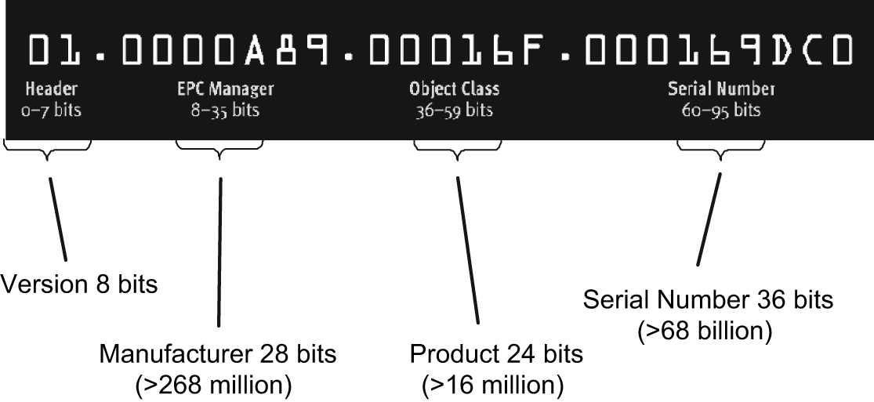

Electronic product code
The EPC primarily consists of the vehicular identification number(VIN).
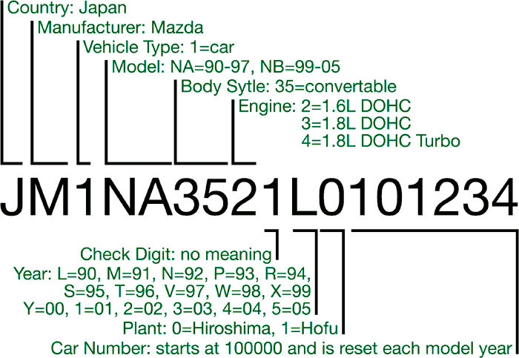 Vehicle Identification Number
The VIN is industry standard and each are unique. Through a table look-up procedure the VIN may be matched against individual vehicle records and all details like type, weight, length, registration, pollution control status and owner’s identification can be retrieved. 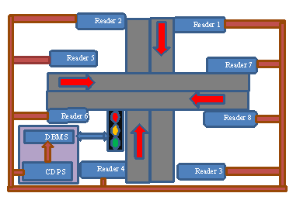

Architecture Of Itcs

The data obtained is then sent immediately to the CCS by a wireless or wired channels, as found convenient at that location. The CCS contains a central database processing system(CDPS) for processing vehicular data and a decision making section(DMS) for controlling the traffic signal.
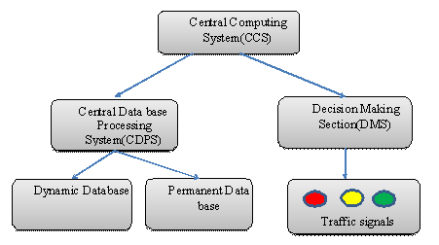Components of ITCS
The CDPS consists of two parts:
- Dynamic database
- Permanent database
Dynamic database where the records of vehicles currently stored and a permanent database that stores the records of all vehicles that have passed the crossing.
The dynamic database divided into a number of parts. It arranges the EPC data of vehicles according to their path and direction of level. Whenever the vehicle moves towards or away from their crossing, the two readers in its path detect it and convey the obtained data to the CCS with some time gap in between. The order of response of the two readers determines the direction of travel of the vehicle. The vehicular data is then sent any one part of database corresponding to it’s path and it’s direction of travel.

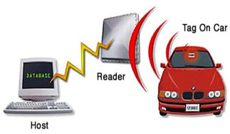
Principle Of ITCS

At each instant, the CDPS checks the data in various parts of the dynamic database and computes the volume of traffic for all the roads converging at the crossing. It then sends the computed information to the DMS of the CCS, which operates the traffic signal according to the current volume of traffic, showing the green light in the direction of maximum traffic.
Order Of Priority
The volume of traffic is not calculated simply by the number of vehicles but by a complex set of equations that take into account predefined factors including:
- Type of vehicle: whether it is a smaller vehicle like a scooter or a car or a larger vehicle like a bus or a truck. Emergency vehicles can be given unrestricted passage.
- Priority assigned to the vehicle: each type of vehicle is assigned a specific priority based on it’s size, frequency of that vehicle at the crossing, time of the day and other factors.
- To the path of travel: this factor becomes essential when both the roads intersecting at the crossing are not to the same importance. Example the intersection of a national high way with an ordinary road.
- Time: the time of the day and day of the week.
Decision Making System
The decision making system (DMS) contains a decision making algorithm that determines how the traffic lights are operated. The decision making algorithm take care of the following factors:
- Depend upon volume: The volume of traffic as received from the CDPS-Green light is shown in maximum volume of traffic.
- Since the volume of the traffic can fluctuate very rapidly, it is not possible to alter traffic signals remain constant before checking for the volume of traffic again.
- A maximum time is set after which a constant traffic signal must change irrespective of volume of traffic. This is done to ensure that no vehicle has to wait too long at the crossing.
- Some interrupts are incorporated to handle emergency situations like an accident or failure of the system. A notification system attached to the interrupts enable external interaction as an emergency cannot be automated and normally requires human intervention.
Each crossing may have a different decision making algorithm depending on the nature of the two intersecting roads for optimizing efficiency. The various factors like maximum and minimum time for each direction must be determined by statistical analysis and research.
Function Of ITCS
The reader is located on both sides of the road. when any vehicle passes along the road the radio frequency wave passes a signal and then detects the vehicle.
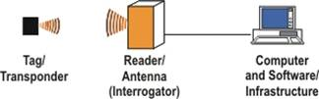

This detected wave contains the EPC code of the vehicle which is unique, which takes place in the central computing system. This data is immediately sent to the central data base processing system. The CDPS contains two data base namely , dynamic database and permanent database . the dynamic database contains the dynamic data about the vehicle which passed at that moment. Permanent database contains details about all the vehicle. After sometimes the data from the dynamic database is sent to the permanent database. This is then passed on to the decision making system. The decision making system is used to calculate the volume of traffic at that instant. This is calculated by priority manner. The most priority is to ambulance , police vehicles , VIP vehicles etc. while considering the time of the day , during day time the most priority is given to two wheelers , school vans, etc. likewise during night hours most priority is given to heavy vehicles. Based on these priority volume of traffic is calculated. The signal lights goes ON and OFF depending on the volume of traffic based on these order of priorities.

- The GREEN light goes ON if the volume of traffic is high on that area.

- The YELLOW light goes ON if the volume of traffic is negotiable.
- The RED light goes On if the volume of traffic is low or nil.

RFID Tagged Vehicle Approaches Road Crossing
Reader tag coupling

Tracked by RFID Reader

Detect EPC data

Central database processing system
Volume of traffic

Decision-making system

system

system

Control signals
Traffic lights

FUNCTION OF ITCS

Merits:
- This system can be used to trace vehicles.
- This system works depending upon the calculating volume of traffic, so travelers may not wait too long time.
- The readers are connected to central computer system, so any one of the reader is failed another side of the reader works for that until correct the repair.
- Do not need human intervention.

Demerits:
- The system has to be check regularly.
- Database maintenance problem.
Conclusion:
An architecture for creating intelligent systems for controlling road traffic is proposed. The system is based on a simple principle of RFID tracking of vehicles, can operate in real time, improve traffic flow and safety, and fully automated, saving costly constant human involvement .The advantages ITCS can provide where demonstrated in detailed which vouches for its effectiveness in traffic management systems. However, it is debatable whether monitoring every vehicle is morally acceptable and whether it is a violation of one of the basic civil rights-privacy.

